Senior Design Documentation

* Angular
* Angular CLI
* Github
* Node JS
* Firefox Web Browser
* mKiosk Firefox addon

Angular-CLI

Install:

***NPM Required***

Where:

You have to go to your local machine terminal and input the following command

npm install -g @angular/cli

How we use it:

ng new Project_Name - - - - - Creates new angular project

ng serve - - - - - This command compiles and serves the app

GitHub

Install:

You can install the desktop version of github from <https://desktop.github.com/> or just use the website. You must be invited to our repo and once you receive that invitation accept and our repo should be available for you to access.

Where:

**For Development:**

We primarily use github in our WebStorm IDE. In WebStorm we can directly interact with our repo.

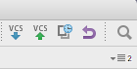

( Blue arrow is a pull from our repo and the green arrow is to push something to the repo)

How we use it:

We use GitHub to bring all the work of the team together. There are a couple steps in how we use the repo for our project.

1. When you open WebStorm you have the option use a repo for to open a project and choose GitHub

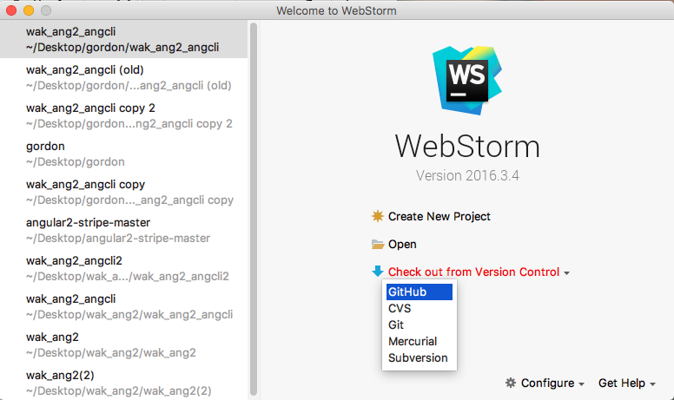

(2) After you clicked GitHub there will be a option for a what repo you would like to use make sure you select the one for the Gordon Water System.

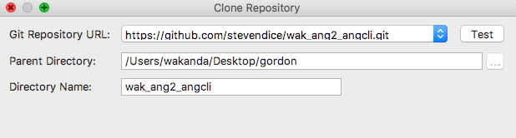

(3) After that you have set up the project in WebStorm has now been set up to use GitHub.

(4) When you make any changes and want to update the repo you must first pull down the repo and rebase then select the files you changed and leave a message.

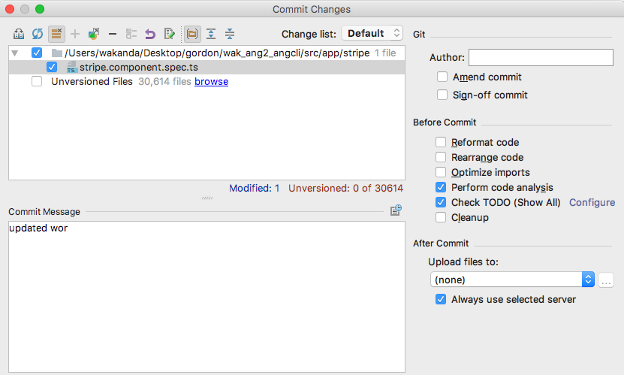

**For Production:**

Go to the Github repo, and select the ‘Clone or download’ button, and then select the ‘Download ZIP’ button.

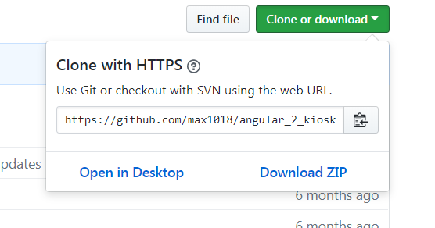

Once you have it downloaded move it from the downloads folder to the user home folder. Then right click and select ‘Extract all’ then ‘extract’.

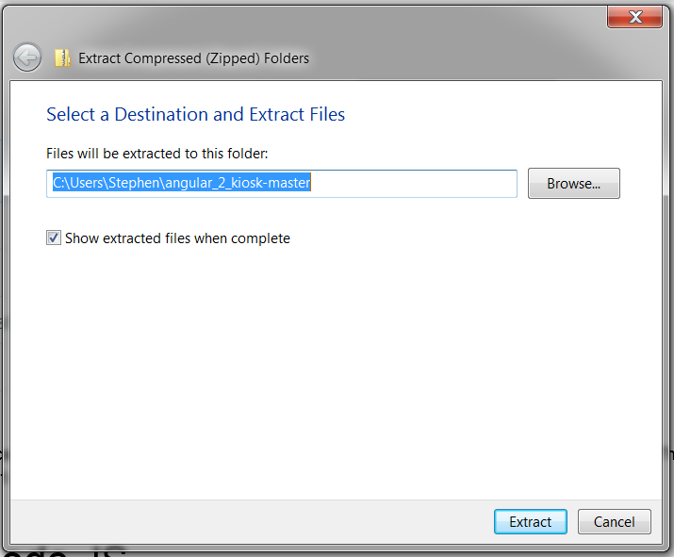

Now, open up the command prompt.

Use the command cd <project_name> to move to the directory containing the application.

Now use the ‘npm install’ command to update the dependencies required for the project.

The application is now ready to be run using the ‘ng serve’ command.

Node JS

Install:

**npm install npm@latest -g**

Where:

You would first do this step in your local machine terminal

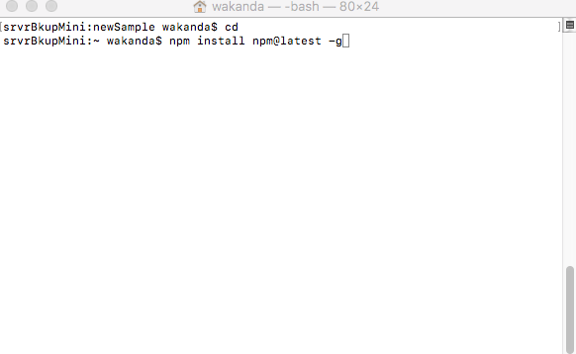

router.get(**'/cof'**, (req, res) => // This is the address we go to retrieve the data on the angular side

// But understand that this really means “api/cof” because we are in the api folder.

*// Get posts from the mock api*

*// This should ideally be replaced with a service that connects to MongoDB*

**axios**.get(**`**${API}**/posts`**) //This is the rest api that we use to bring data into our node js server

.then(**posts** => {

**res**.status(200).json(**posts**.**data**); // if there is no error then post json data to “api/cof”

})

.*catch*(error => {

**res**.status(500).send(***error***) // if there is error then console error

});

});

How we use it:

This is a package manager we use this to add new packages to our node modules. For example we needed to install ag-grid into our node modules we ran the following command in WebStorm.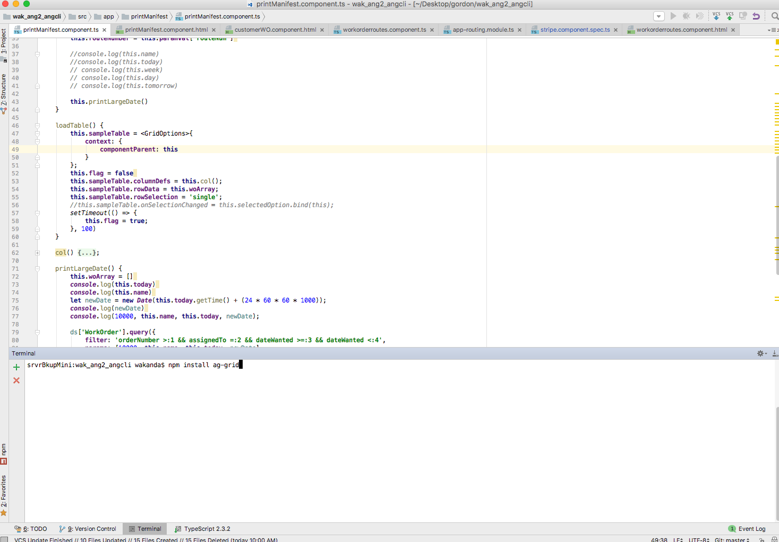

Firefox Web Browser

Install:

First download the Firefox version56.0.2 installer from: <https://support.mozilla.org/en-US/kb/install-older-version-of-firefox>

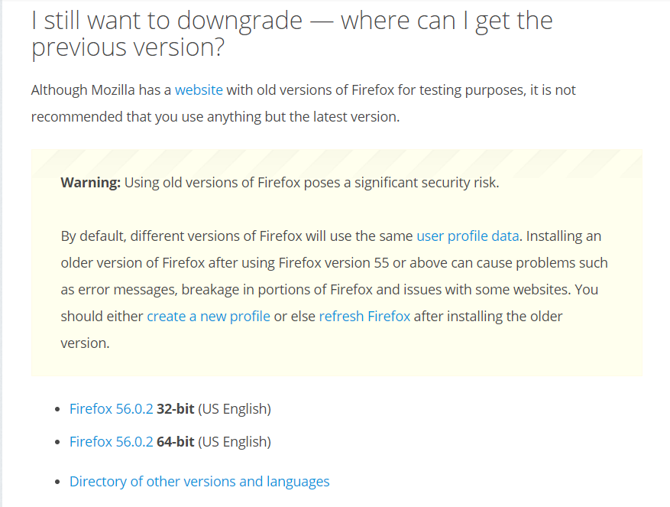

*Note: Ensure you are getting the correct version for your version of Windows 10.

Once downloaded, launch the installer, and select ‘Run’

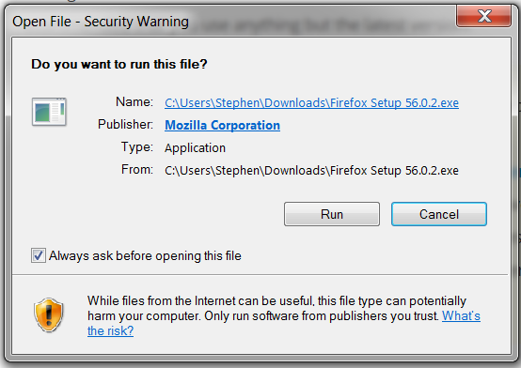

Follow the prompts for a standard installation. Leave the checkbox checked to make Firefox the default browser.

Once Firefox has installed and opened follow the instructions here to disable automatic updates

<https://www.technipages.com/enable-disable-automatic-updates-in-firefox>

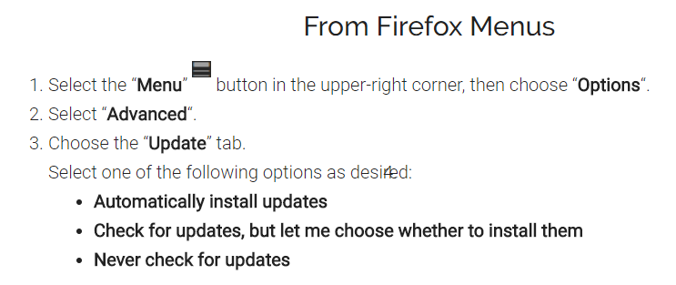

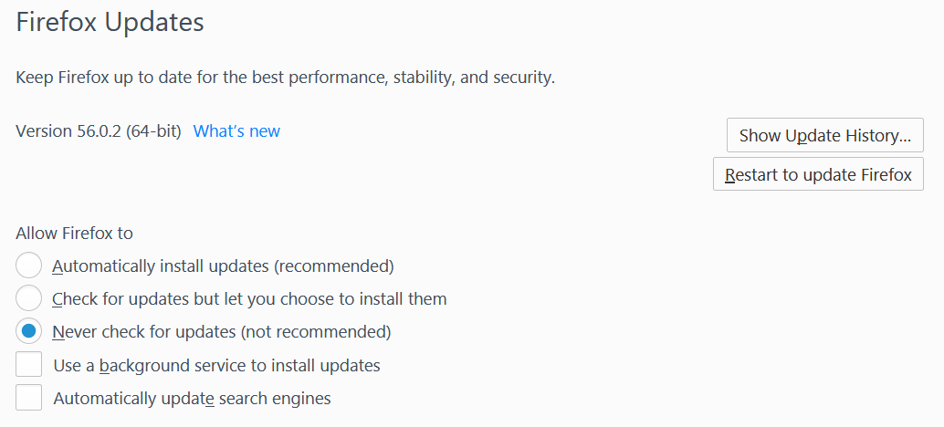

*Note: the reason we don’t want to update Firefox is because the kiosk addon is not compatible with the new version. If at some point in the future it becomes available with it, then it is suggested that you do upgrade to the latest version.

Mkiosk – Firefox Addon

Install:

Open up the Firefox web browser

Go to: <https://addons.mozilla.org/en-US/firefox/addon/mkiosk/> and click the “add to Firefox” button

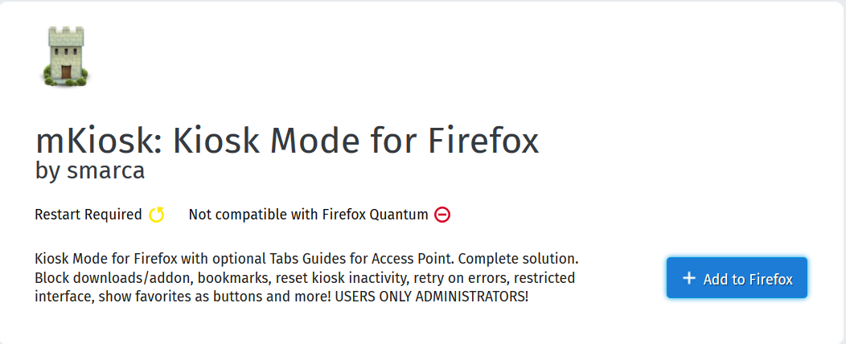

Then click the ‘Add’ button.

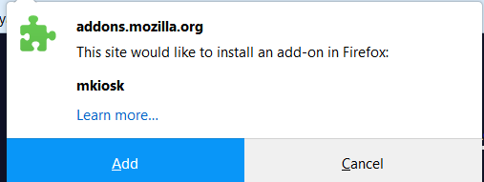

Then close out of Firefox, and restart it.

How to use:

Upon first start up with the addon, you will be prompted for settings.

On the ‘Basic’ tab:

Check the “Always start in fullscreen” box.

Set the Default URL to http://localhost:4200

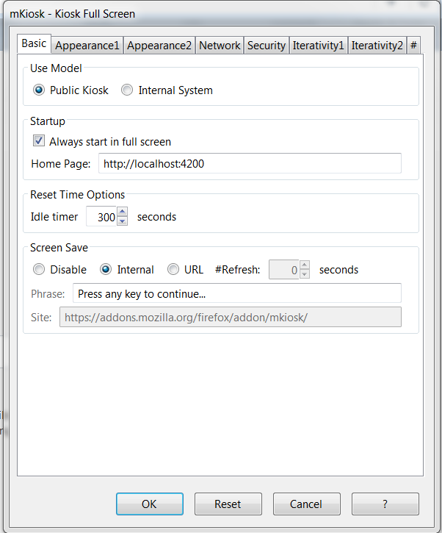

On the Appearance1 tab:

Uncheck the ‘Show Toolbars’ box.

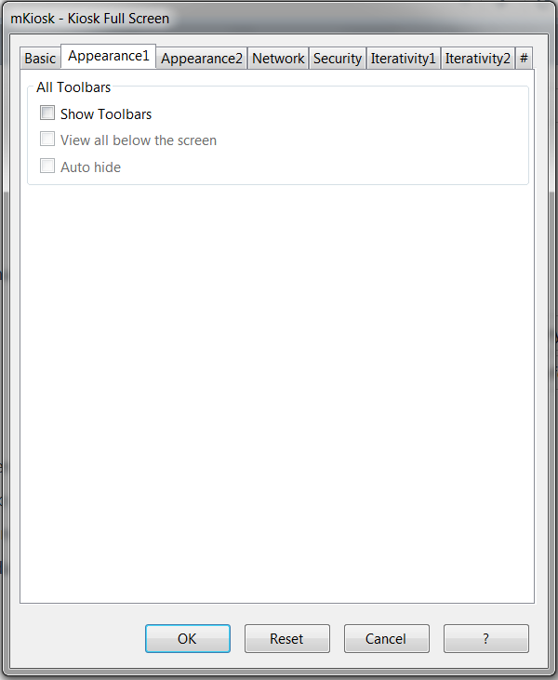

On the ‘Security’ tab:

If you choose to, add a password so the settings cannot be changed by anyone without the pw.

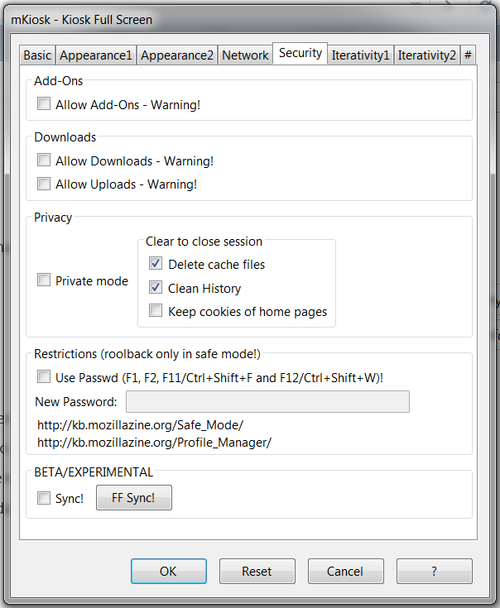

Then select ‘ok’.

Close out of Firefox and reopen it.

Documentation for this addon can be found at: <https://addons.mozilla.org/en-US/firefox/addon/mkiosk/>